Quiz 1 20/2/2020
In the Hypothetical Machine the contents of memory was as shown. And PC contents is 300. Show the contents of memory and PC, AC, IR after execute three instructions (three fetch cycle and there execute cycle)

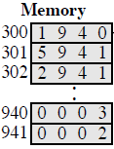

ANSWER:-
First Instruction:
- Fetching:
AC: 0000 IR: 1940 PC: 300
940: 0003 941: 0002
- Execution:
AC: 0003 IR: 1940 PC: 300
940: 0003 941: 0002
Second Instruction:
- Fetching:
AC: 0003 IR: 5941 PC: 301
940: 0003 941: 0002
- Execution:
AC: 0005 IR: 5941 PC: 301
940: 0003 941: 0002
Third Instruction:
- Fetching:
AC: 0005 IR: 2941 PC: 302
940: 0003 941: 0002
- Execution:
Ac: 0000 IR: 2941 PC: 302
940: 0003 941: 0005

Show the contents of PC , AC and IR and memory after the execution of each instruction of the following program on the Hypothetical Machine:
300 LOAD 550
301 ADD 551
302 STORE 600

Where the contents of memory at 550 is 3 and at 551 is 4.

ANSWER:-
First Instruction:
- Fetching:
AC: 0000 IR: 1550 PC: 300
550: 0003 551: 0004 600: 0000
- Execution:
AC: 0003 IR: 1550 PC: 300
550: 0003 551: 0004 600: 0000
Second Instruction:
- Fetching:
AC: 0003 IR: 5551 PC: 301
550: 0003 551: 0004 600: 0000
- Execution:
AC: 0007 IR: 5551 PC: 301
550: 0003 551: 0004 600: 0000
Third Instruction:
- Fetching:
AC: 0007 IR: 2600 PC: 302
550: 0003 551: 0004 600: 0000
- Execution:
AC: 0000 IR: 2600 PC: 302
550: 0003 551: 0004 600: 0007

The following figure provide the main characteristics of Hypothetical Machine.
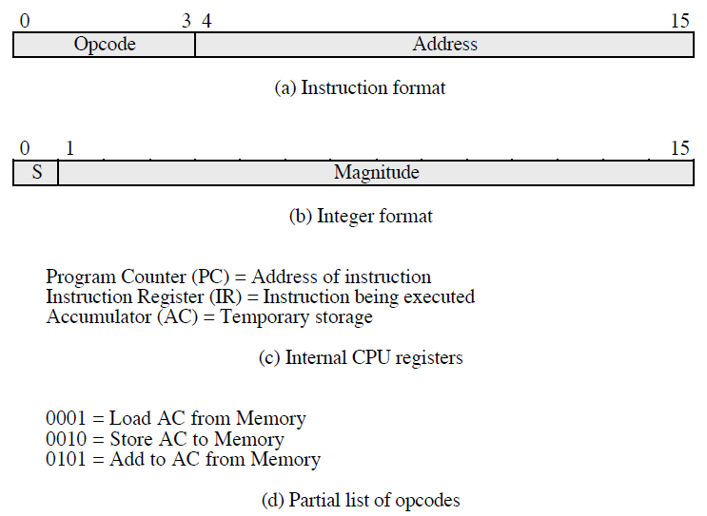

The hypothetical machine also has two I/O instructions:
0011 = load AC from I/O
0111 =store AC to I/O
In these case, the 12-bi address identifies a particular I/O device. Show the program execution for the following program:
1. Load AC from device 5.
2. Add contents of memory location 940.
3. Store AC to device 6.
Assume that the next value retrieved from device 5 is 3 and that location 940 contains a value of 2.

ANSWER:
MEMORY
300 | 3005
301 | 5940
302 | 7006

After executing the three instructions:
device 5: 0003
940: 2
device 6: 0005

